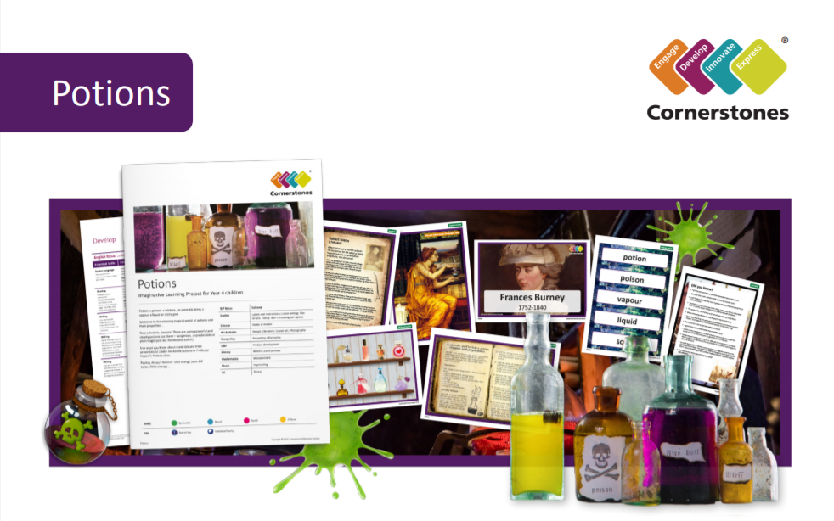

Poisonous potions, aromatic brews, vapour or a sticky goo…..Welcome to the amazing world of potions! We will be reading Alice’s Adventures in Wonderland and learning all about solids, liquids and gases. Becoming super scientists, we will investigate chemical reactions and states of matter. As our INSPIRE, WE will design our own potions and bottles. Will your potion be full of kindness or full of witches fingers and toads warts?

ILP focus | ILP focus
English | Narrative and Information Texts
Geography | River Study
Art & Design | Painting
Computing | How the internet works
Music | Glockenspiels
PE | Dance and Gymnastics
PSHE | Jigsaw
RE | What do Hindus believe God is like?
Help your child prepare for their project:
‘Double, double toil and trouble; fire burn and cauldron bubble.’ Why not hunt around the house to track down a wide variety of items and sort them into solids, liquids and gases? You could also sketch interesting bottles or containers that you have at home. Alternatively, you could try baking something new together, thinking about how the ingredients change when you mix and cook them.

