

Monday 12th October 2020

Dear Parents / Carers
Year 3 Ancient Greek day
Our Year 3 project this term is Ancient Greece and we have organised a day event with the children to take place on Tuesday 20th October. They will take part in a series of events including a mini-Olympics and decorating shields with Greek phrases.
We would really appreciate it if the children could dress appropriate in clothes similar to those of the ancient Greeks. Below are some suggestions of what the children could wear.
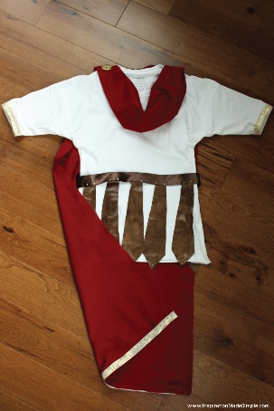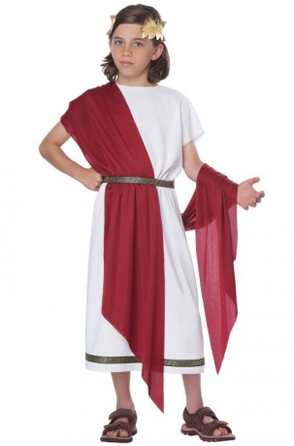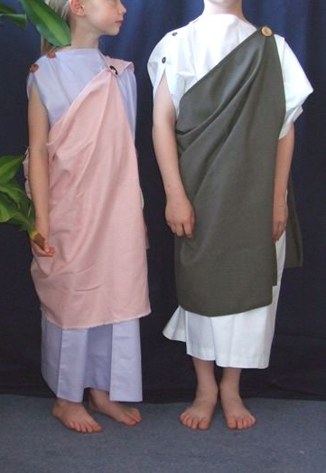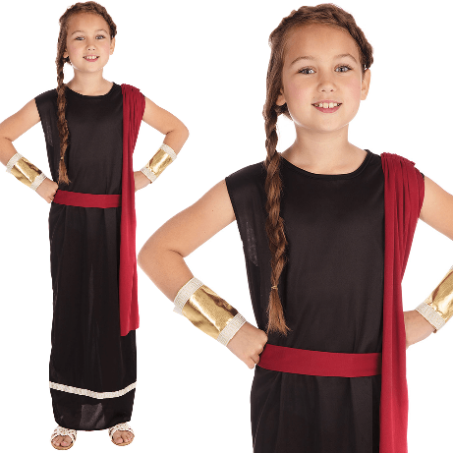

As this activity is taking place on a Tuesday, please note the children need to bring trainers for P.E and wear shorts underneath but not their full P.E. kit.
On a further note, Thursday 22nd October is school photo day but also our dojo treat day. Please could the children bring slippers to wear after their school photos for our movie in the afternoon. The children do not need to bring any snacks for the dojo treat.
Many thanks for your help with this.
Kind regards,

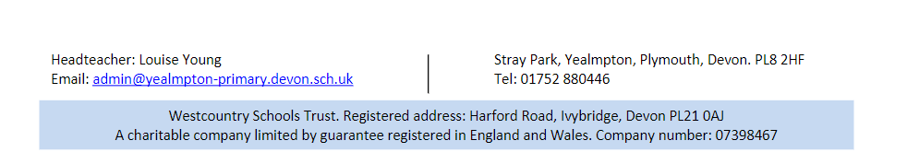
Miss Leverson
Year 3 Teacher

