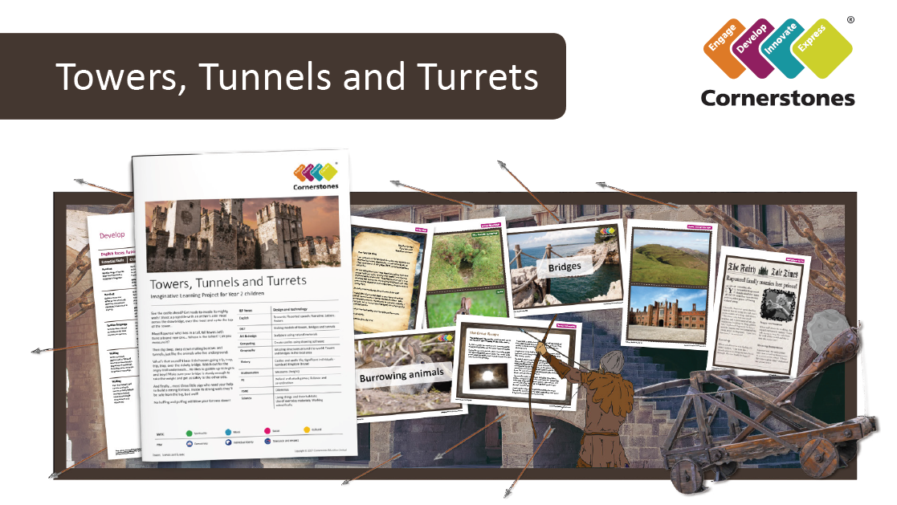

Climbing the battlements or tunnelling in the ground, there’s a whole world of adventure and fun to be found.
This term we will be exploring towers and tunnels around the world and castles and battlements from long ago. We’ll learn the different parts of a castle and describe how they have changed over time. Using a range of materials, we will build junk model castles and test the strength of our structures. We will be learning the story of Jack and the Beanstalk and we will invent our own versions. We’ll also learn about some burrowing animals and write information books inspired by them. Maps and photographs will help us to find out about the tallest towers and longest tunnels in the world.

ILP Focus | DT
English | Jack and the Beanstalk (Narrative)  Poems on a theme (Poetry)  Burrowing Animals (Non Chronological Reports)
DT | Making models of castles
Computing | What is a computer?
History | Castles and Castle life, Significant individuals (Isambard Kingdom Brunel)
Maths | Place value to 100  Addition and Subtraction
PE | Tennis and Football
PSHE | Jigsaw Puzzle 1 – Me in My World
RE | Who is Muslim and how do they live?
Science | Everyday Materials

